🗑️ Week 2 – Waste Audit & Assessment Report
Objectives
- Identify types and quantities of waste generated in the school.
- Assess current disposal practices and plastic-use habits.
- Establish baseline data for later comparison.
Methodology
- Survey & Observation
  - Conducted across classrooms, corridors, canteen, and common areas.
  - Students recorded daily waste in three categories:
    - 🟢 Biodegradable (food scraps, banana peels)
    - 🔵 Recyclable (paper, cardboard, recyclable plastics, old torn-out books from library)
    - ⚫ non-recyclable (wrappers containing foil, mixed waste, single used plastic bags, used pens, dried out markers)
- Data Collection Tools
  - Student monitoring sheets.
  - Monitor “Sahayaks”-supervised bin checks.
  - Short questionnaire on plastic-use habits (water bottles, lunch boxes, bags).
Waste Category | Avg. Daily Quantity | Common Sources
🟢 Biodegradable | 4–5 kg | Canteen leftovers, fruit peels
🔵 Recyclable | 2–3 kg | Paper scraps, notebooks, cardboard
⚫ Non-Recyclable | 3–4 kg | Plastic wrappers, single-use bottles

Plastic-use pre-survey outcomes :
- 65% of students use single-use plastic water bottles.
- 40% bring food in disposable plastic packaging.
- Only 25% regularly use reusable lunch boxes and cloth bags.

Key Observations
- Biodegradable waste is the largest category, mainly from food areas.
- Recyclable paper waste is significant but often mixed with non-recyclables.
- High dependence on single-use plastics among students.
- Awareness of proper segregation is low; bins often contain mixed waste.
Analysis:
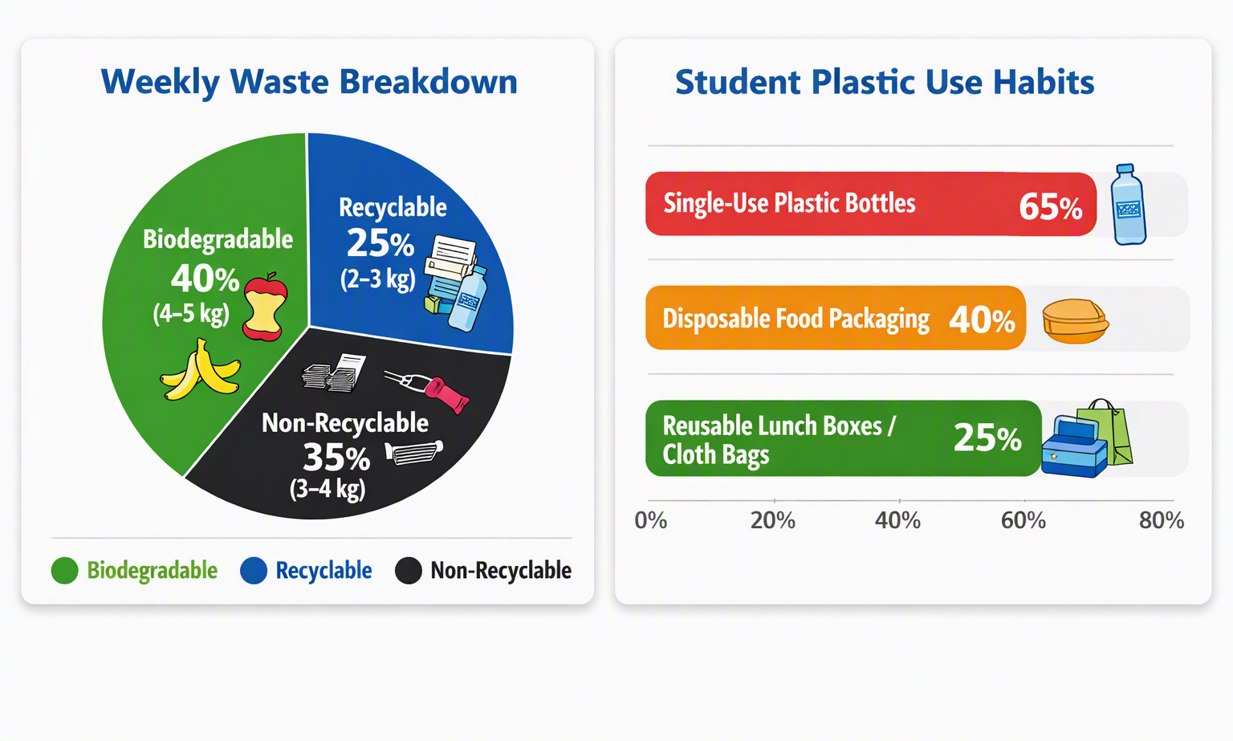
The pie chart showing the weekly waste breakdown (Biodegradable 40%, Recyclable 25%, Non-Recyclable 35%).
The bar graph highlighting student plastic-use habits (65% single-use bottles, 40% disposable packaging, 25% reusable alternatives).

Expected Outputs
- Waste Audit Report (baseline data recorded).
- Survey Analysis (student plastic-use habits documented).
- Charts & Graphs for awareness campaigns in Week 3.

